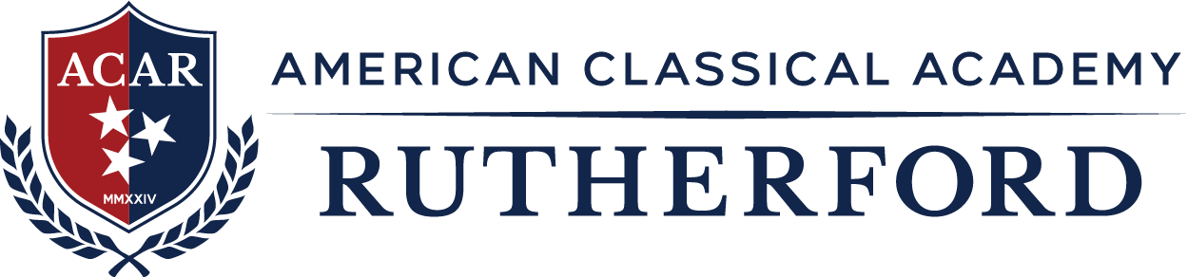

Board of Directors Meeting Book

Agenda – February 19, 2026

The meeting is held virtually via a Microsoft Teams Connection accessible: here

Call to Order: Tricia Stickel, Board President

- Attendance and Introductions
- Reading of the School Mission Statement

- School Mission Statement:

The mission of American Classical Academy Rutherford is to train the minds and develop character in students through a content-rich Classical Education in the liberal arts and sciences utilizing instruction in the principles of moral practices and civic virtue.

- Public Comment

- Approval of Agenda and Minutes

  - Approval of Agenda

  - Approval of January 15, 2026 Minutes

- Reports and Resolutions

  - All Resolutions and Reports

    - Board Chair Report
      - Head of School/School Leader Succession Plan – Search Discussion
      - Audit Report
      - Board Member Resolutions

    - Financial Reports
      - Review January 2026 Financials and Support

    - State of the School – Interim Head of School, Dr. Allen Beck

      - Head of School Report – February 2026
        - Student Enrollment/Absenteeism/Discipline Report
        - Marketing Update
        - Review of Compliance Listing
        - Food Service Amendment Submitted
        - Staffing Updates
        - RCS Visit
        - K-12 Visit

- Reminder of Next Meeting

  - March 19, 2026 at 6:30pm

- Adjournment: Tricia Stickel, Board President

