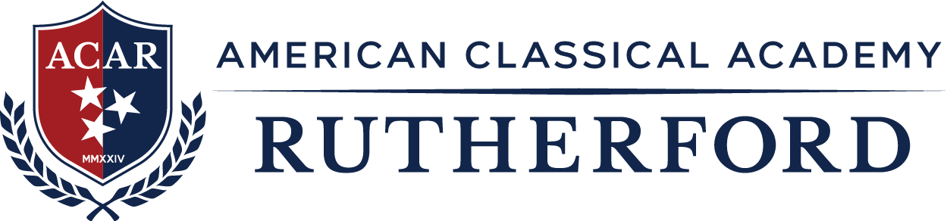

Board of Directors Meeting Book

Agenda – March 19, 2026

The meeting is held virtually via a Microsoft Teams Connection accessible: here

Call to Order: Tricia Stickel, Board President

- Attendance and Introductions
- Reading of the School Mission Statement

- School Mission Statement:

The mission of American Classical Academy Rutherford is to train the minds and develop character in students through a content-rich Classical Education in the liberal arts and sciences utilizing instruction in the principles of moral practices and civic virtue.

- Public Comment

- Approval of Agenda and Minutes

  - Approval of Agenda

  - Approval of February 19, 2026 Minutes

- Reports and Resolutions

  - All Resolutions and Reports

    - Board Chair Report

    - Financial Reports
      - Review February 2026 Financials and Support

    - State of the School Report
        - Student Enrollment/Absenteeism/Discipline Report
        - Marketing Update
        - Review of Compliance and District Requirements
        - Grant and Federal Funding Updates
        - Staffing Updates - New/Removal Staff and Stipend

- Reminder of Next Meeting

  - April 16, 2026 at 6:30pm

- Adjournment: Tricia Stickel, Board President

